# **CSC 431** Coral Gables Live Music Booking Application System Architecture Specification (SAS)

**Team 7**

| Alan Fiore | Software Developer |
| --- | --- |
| David Erulker | Software Developer |
| Tal Ram | Software Developer |

# Version History

| Version | Date | Author(s) | Change Comments |
| --- | --- | --- | --- |
| 1 | 04/07/2025 | Alan Fiore, David Erulker, Tal Ram | Initial Draft - system overview |
| 2 | 04/11/2025 | Alan Fiore, David Erulker, Tal Ram | Structural design / sequence diagrams |
|  |  |  |  |
|  |  |  |  |

# Table of Contents

1. System Analysis 6

1.1 System Overview 6

1.2 System Diagram 6

1.3 Actor Identification 6

1.4 Design Rationale 6

1.4.1 Architectural Style 6

1.4.2 Design Pattern(s) 6

1.4.3 Framework 6

2. Functional Design 7

2.1 Diagram Title 7

3. Structural Design 8

# Table of Tables

| **Table Number** | **Table Title** | **Page Number** |
| --- | --- | --- |
| 1.3 | Actor Identification | 7 |
| 1.4.1 | Architectural Style | 7 |
| 1.4.2 | Design Pattern(s) | 8 |
| 1.4.3 | Framework | 8 |

# Table of Figures

| **Figure Number** | **Figure Title** | **Page Number** |
| --- | --- | --- |
| 1.2 | System Diagram | 6 |
| 2.1 | Artist Profile Management | 9 |
| 2.2 | Venue Profile Management | 10 |
| 2.3 | Geolocation Services for Venue and Artist Discovery | 11 |
| 2.4 | In-App Messaging System | 12 |
| 2.5 | Integrated Payment Processing | 13 |
| 2.6 | Booking Management System for Venues | 14 |
| 3 | Structural Design | 15 |

### 1. System Analysis

#### 1.1 System Overview

The Coral Gables Live Music Booking Application is a mobile platform that connects local artists with venues through profile management, geolocation discovery, and integrated booking workflows. Using a 3-tier layered architecture, the system separates presentation (React Native frontend), application logic (Node.js/Express backend), and data storage (MongoDB) to achieve scalability and maintainability.

#### 1.2 System Diagram

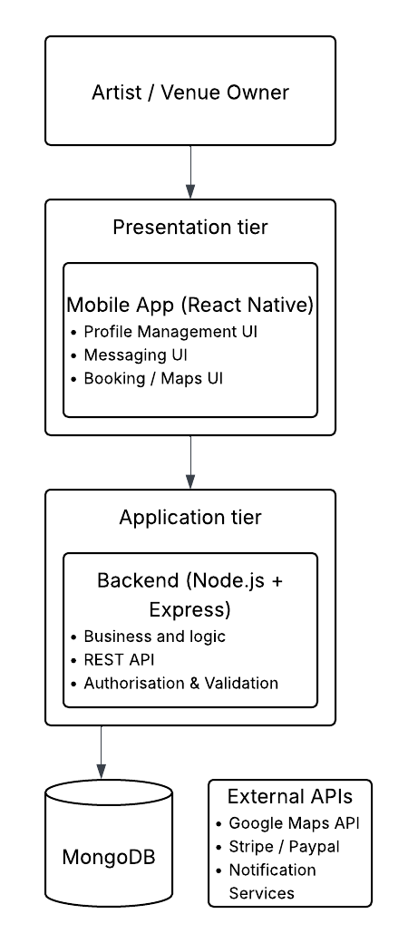

#### 1.3 Actor Identification

| **Actor Type** | **Actor** | **Roles and Responsibilities** |
| --- | --- | --- |
| Primary | Artists | Create profiles, search venues, negotiate bookings |
| Primary | Venue Owners | Manage venue profiles, handle booking requests |
| Secondary | Payment Processors (Stripe/PayPal) | Handle financial transactions |
| Secondary | Google Maps API | Provide geolocation services |

Additional Context:

* Artists and venues interact via a unified interface, reducing friction in booking workflows.
* Third-party services (Stripe, Google Maps) are abstracted behind facades to simplify integration.

#### 1.4 Design Rationale

##### 1.4.1 Architectural Style

| **3-Tier Layered Architecture** | | |
| --- | --- | --- |
| **Architecture Tier** | **Technology** | **Responsibilities** |
| Presentation Tier | React Native | Handles the user interface, providing a native-like experience on iOS and Android. |
| Application Tier | Node.js + Express.js | Manages business logic, API endpoints, and server-side operations. |
| Data Tier | MongoDB | Stores application data (user profiles, venue info, booking details). |

Justification:

* Decoupling tiers allows independent scaling (e.g., backend servers vs. frontend updates).
* Mongoose adds validation (e.g., ensuring artist profiles include contact info) without sacrificing NoSQL agility.

##### 1.4.2 Design Pattern(s)

| **Pattern** | **Application** | **Justification** |
| --- | --- | --- |
| Observer | Notify artists/venues about booking status changes. | Keeps status changes separate, so updates happen right away. |
| Facade | Simplify payment processing and geolocation APIs behind unified interfaces. | Reduces complexity for artists/venues interacting with Stripe/PayPal or Google Maps |
| Iterator | Traverse search results (venues/artists) consistently, regardless of data source. | Standardizes access to collections like venue/artist lists. |
| Decorator | Dynamically add features like promotional pricing and verified users. | Extends functionality without modifying core classes |

Impact:

* Observer/Facade enhance reliability in critical paths (payments/notifications).
* Iterator/Decorator improve maintainability for evolving business rules.

##### 1.4.3 Framework

| **Framework** | **Purpose** | **Selection Rationale** |
| --- | --- | --- |
| React Native | Enables cross-platform mobile development with reusable components and native performance. | Selected to efficiently support both iOS and Android platforms under project constraints. |
| Express.js | Provides a lightweight web framework for building robust APIs and handling HTTP requests. | Chosen for its flexibility and seamless integration with Node.js backend requirements. |
| Mongoose | Simplifies MongoDB interactions in schema validation and data modeling. | Supports data integrity and streamlines database operations for the application. |

Tradeoffs Considered:

* React Native vs. Flutter: Chose RN for larger community support in JavaScript ecosystem.
* Express.js vs. NestJS: Opted for Express due to simpler learning curve and project scope.

### 2 Functional Design

#### 2.1 Artist Profile Management

The system allows artists to create and manage detailed profiles, including bios, music genres, performance samples (audio/video links), and availability calendars. Profiles are searchable by venues and support verification badges for authenticity. Artists can edit their information, set booking preferences (e.g., minimum fees, travel radius), and link social media accounts for credibility.

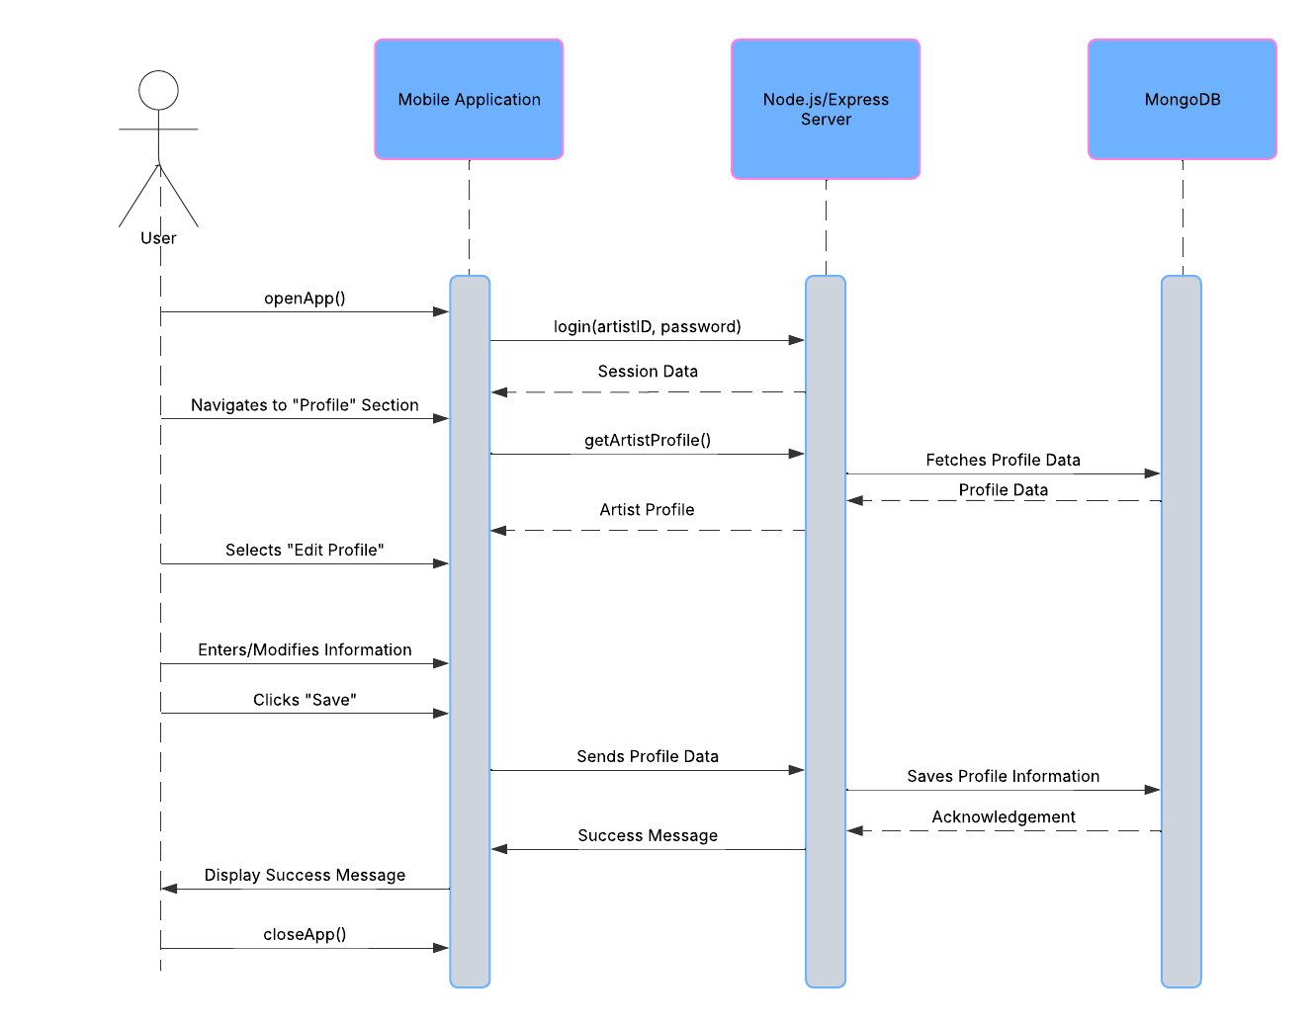

#### 2.2 Venue Profile Management

Venues can register and maintain profiles featuring photos, capacity, amenities (e.g., stage size, sound equipment), and booking policies. Owners can define pricing tiers, blackout dates, and preferred artist genres. Real-time availability sync ensures no double bookings, while ratings/reviews from past events enhance credibility.

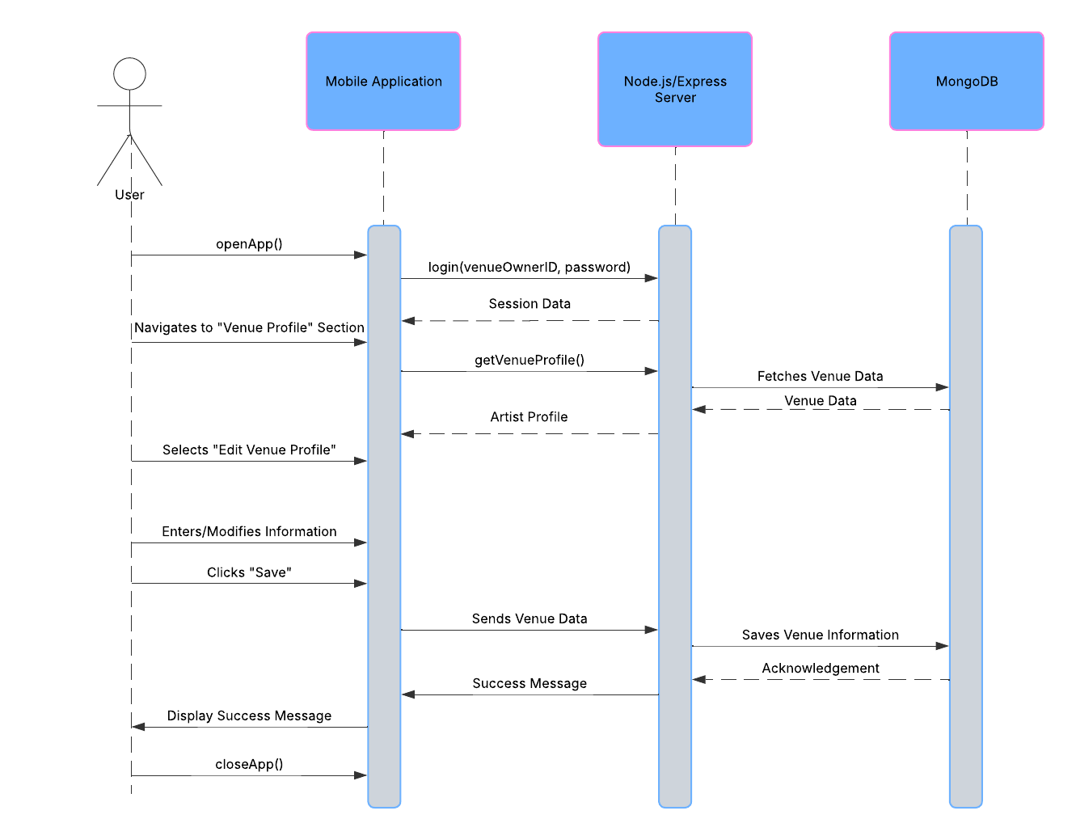

#### 2.3 Geolocation Services for Venue and Artist Discovery

Powered by Google Maps API, the system enables location-based searches with filters (distance, venue type, artist genre). Artists see nearby venues on an interactive map, while venues discover local talent. Proximity-based notifications alert users to new opportunities within their radius.

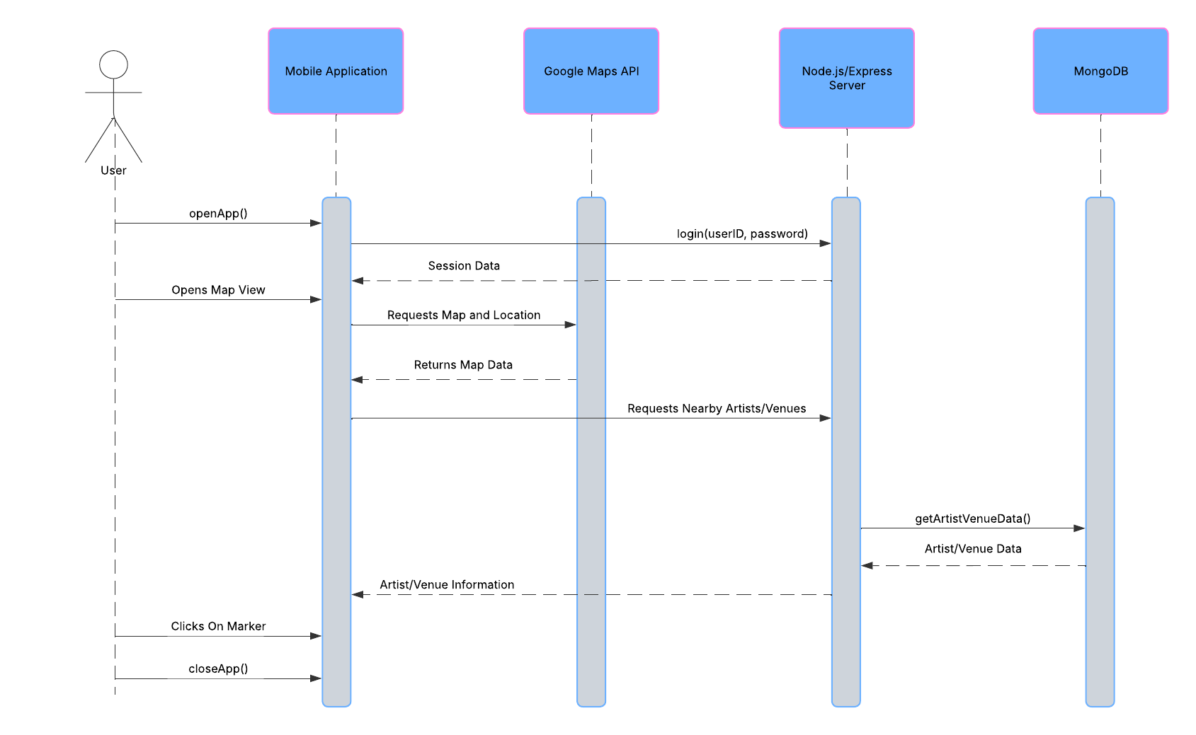

#### 2.4 In-App Messaging System

A real-time chat interface facilitates direct negotiation between artists and venues. Messages support attachments (contracts, rider documents) and include read receipts. Automated reminders prompt users to respond, and conversation history is preserved for future reference.

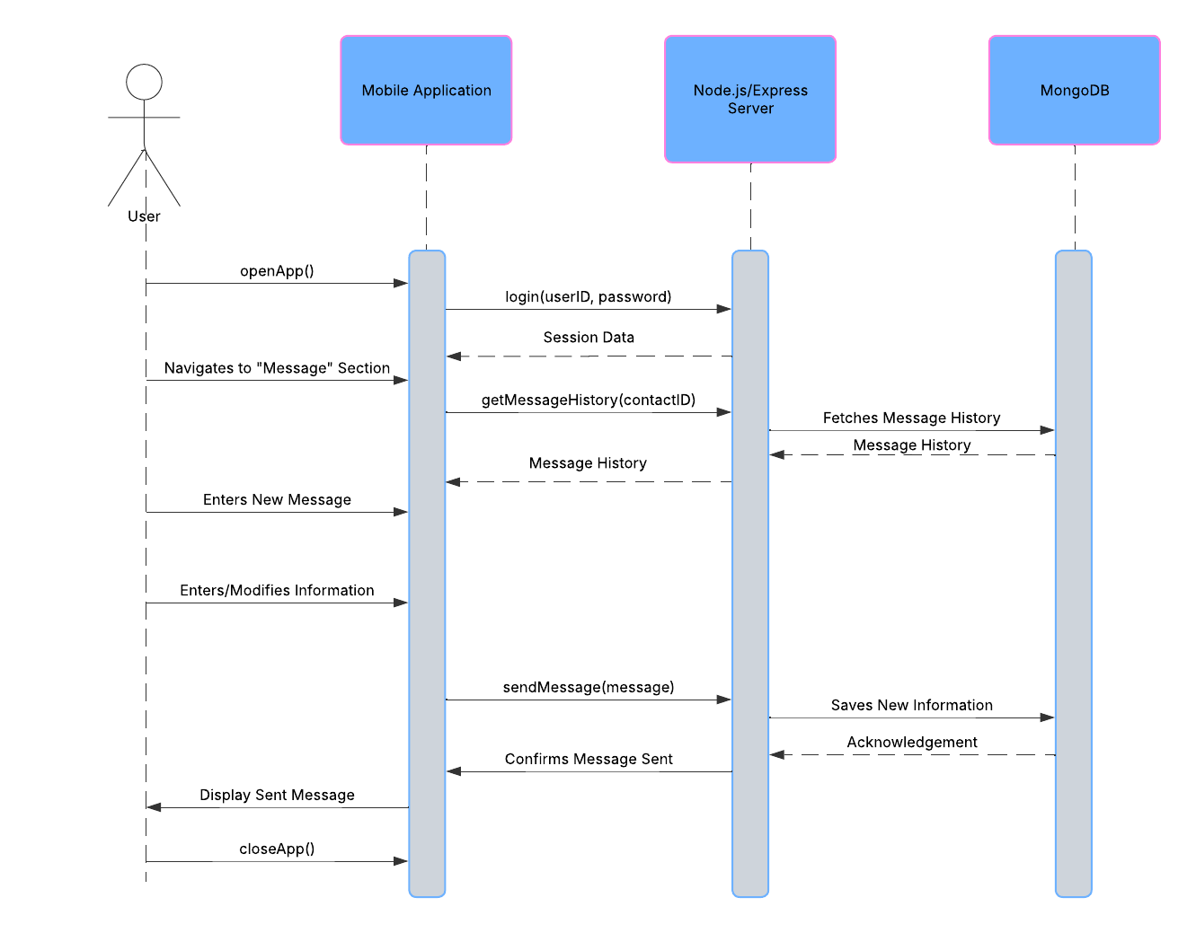

#### 2.5 Integrated Payment Processing

Secure payments are handled via Stripe/PayPal, supporting deposits, splits (e.g., artist/venue/platform fees), and refunds. Escrow options hold funds until gig completion, with automated payouts triggered by confirmation from both parties. Receipts and tax documentation are generated automatically.

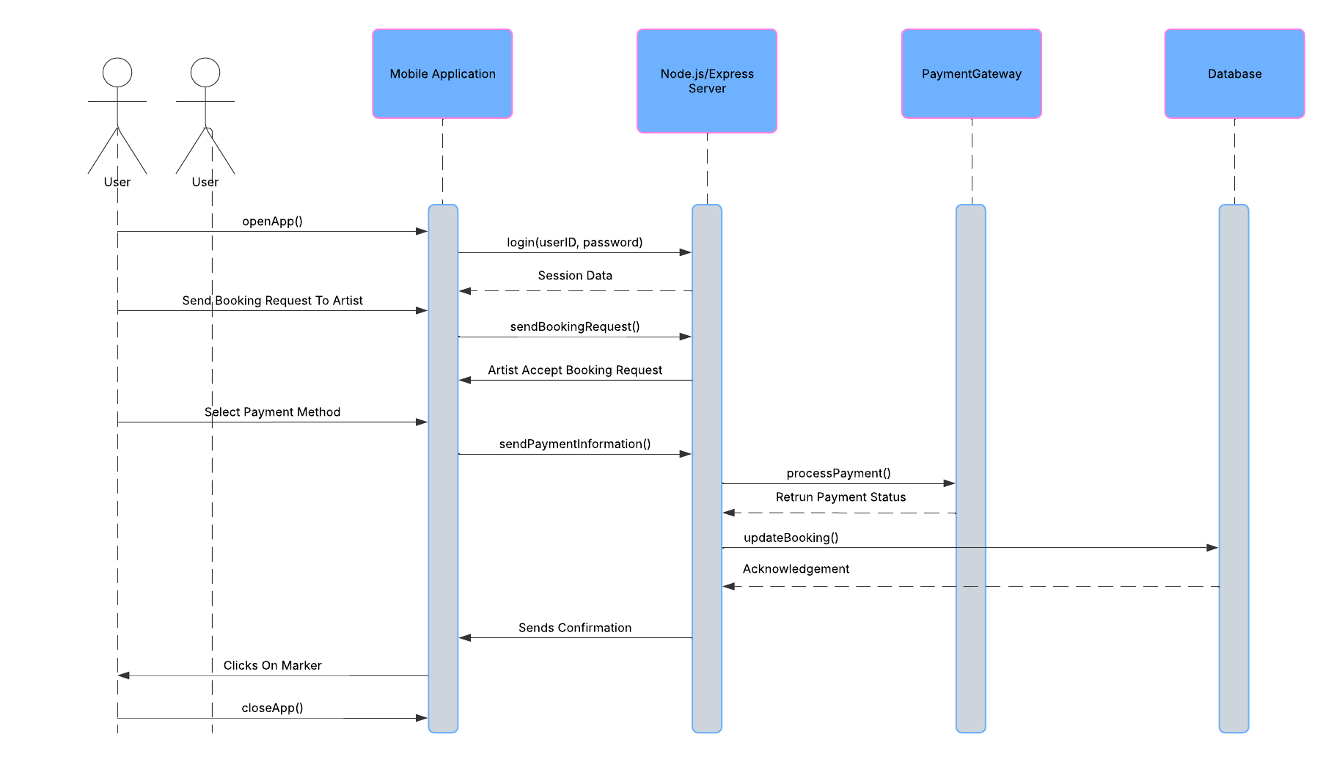

#### 2.6 Booking Management System for Venues

Venues receive, approve, or decline booking requests through a centralized dashboard. Conflict detection prevents overlapping events, and calendar integrations (Google Calendar, Outlook) sync bookings. Post-event, venues can leave artist reviews and manage invoices/payouts.

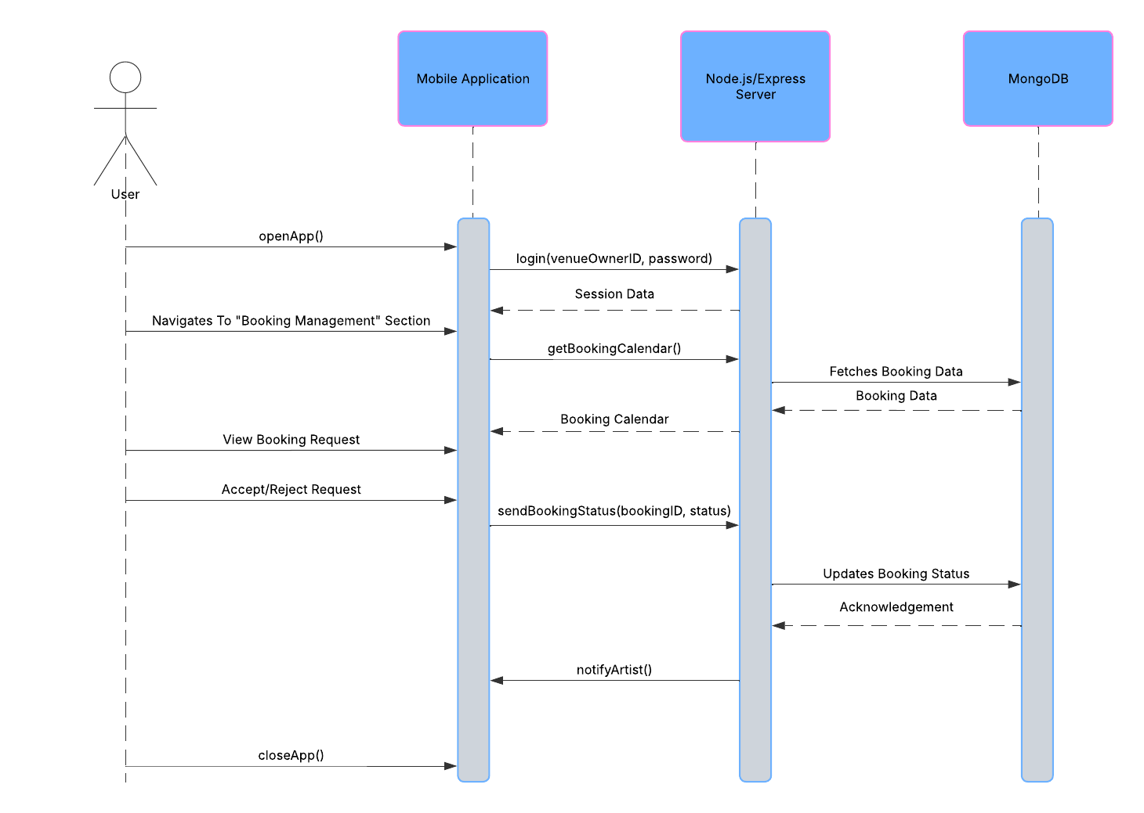

#### 

### 3. Structural Design: Context Model and Class Diagram

#### Context Model

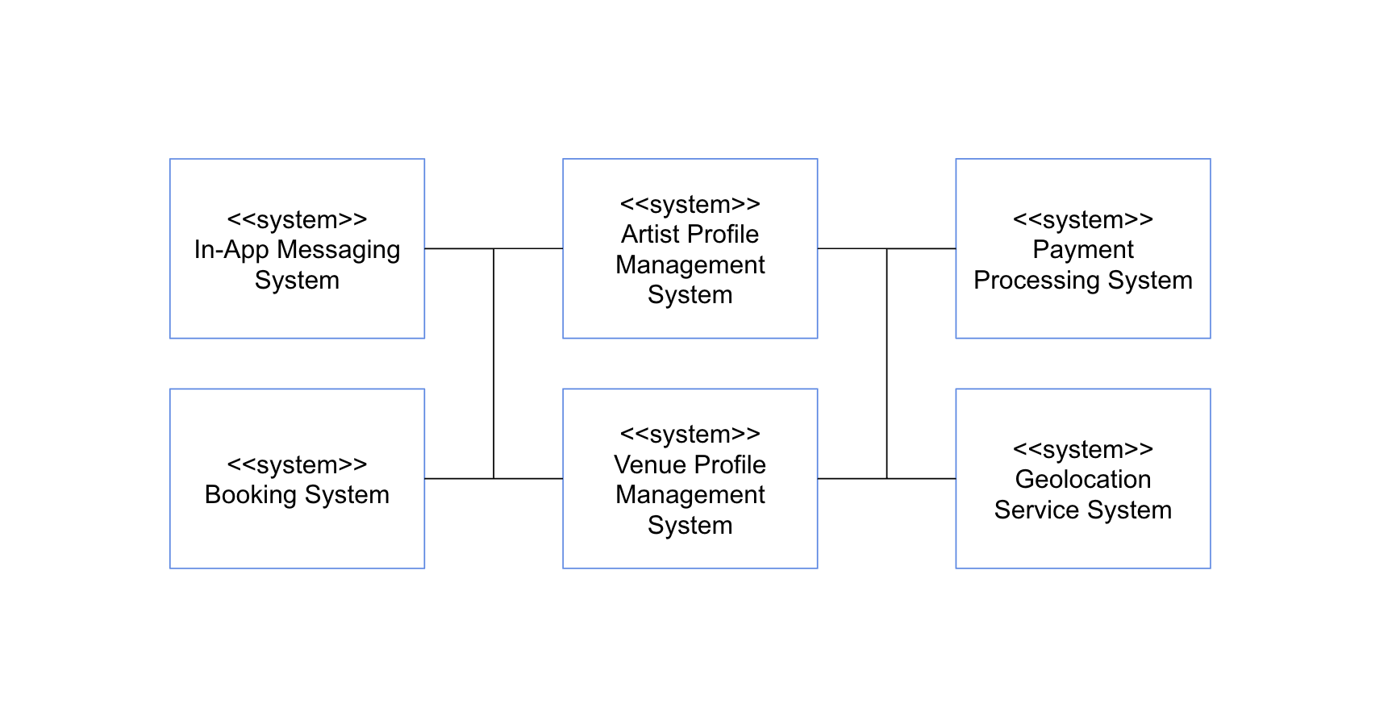

#### Class Diagram

